**Design Document**

**Event website**

Made by:

Atanas Naydenov

Dmitrii Orlov

Dimitar Markov

Hristiqn Vasilev

**Content**

1. Project Banana Description p. 3
2. The Target Audience p. 4
3. Sitemap p. 5
4. Wireframes p. 6- 8
5. Visual Design p. 9- 11

**Event Website Description**

Buid a website for organisng an event. The customers are going to be able to gather information about the event, buy tickets and reserve camping. Somebody redact these shits.

**The Target Audience**

The website is targeted to every king of people, music enthusiasts, people who want to learn new things, who are interested in the music culture and different aspects. Needs redaction.

**Sitemap**

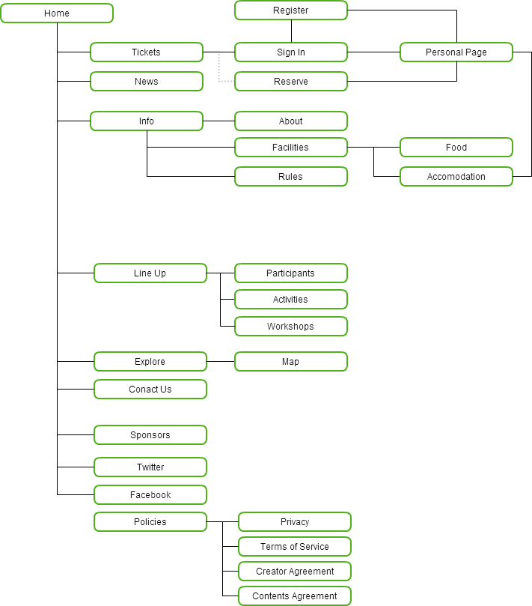

**Wireframes**